How to Legally Decline a Vaccine
STEP 1
- DO NOT ‘refuse’ a vaccine. Otherwise, you will be considered belligerent.
- Instead, you can politely decline the service by doing the following:

STEP 2
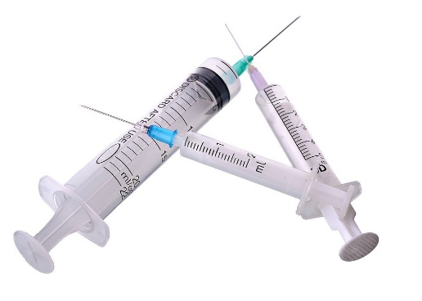
- Ask the doctor “Does the vaccine have MRC-5 in it?” (They all do!)
(These are aborted foetal cells and other DNA.)
- If the vaccine contains MRC-5 you have the RIGHT to decline!

STEP 3
- Also ask “Is there a possibility of a ‘LATROGENIC REACTION?’ from the vaccine?”
(This is an adverse reaction caused by multiple compounds or drugs interacting with each other.) (They all do!)
- When the doctor says, “Yes it does”, that is your Get out of the vaccine free card.
- Thank the doctor for their offer and walk away.

Remember doctors have sworn the Hippocratic Oath (Do no harm). They must honour it. This is how we can legally and respectfully decline their offered mandated services and there is absolutely nothing they can do about it.

PLEASE SHARE WITH EVERYONE YOU CARE ABOUT!

Copied from: Holistology Natural Healing
www.facebook.com/holistology

